Question 1 .2. To execute the following Nmap scanning techniques commands in Kali Linux operating Systems.

(i)TCP syn port scan

(ii)TCP connect port scan

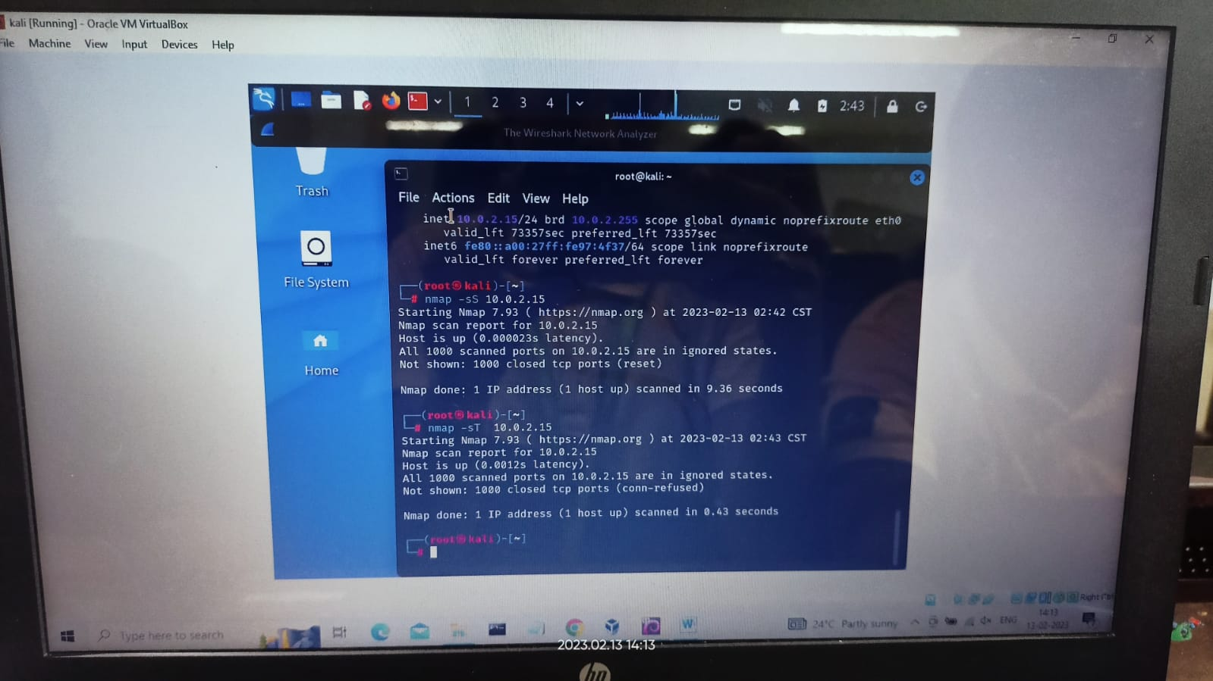

Question 2 2.A penetration tester hired to evaluate the security of a web application running on a server with Kali Linux operating systems. His task is to perform a vulnerability analysis of the web application by using CGI scanning with Nikto. How would you approach this task and what steps would you take to ensure that you are able to find all the vulnerabilities in the web application effectively?

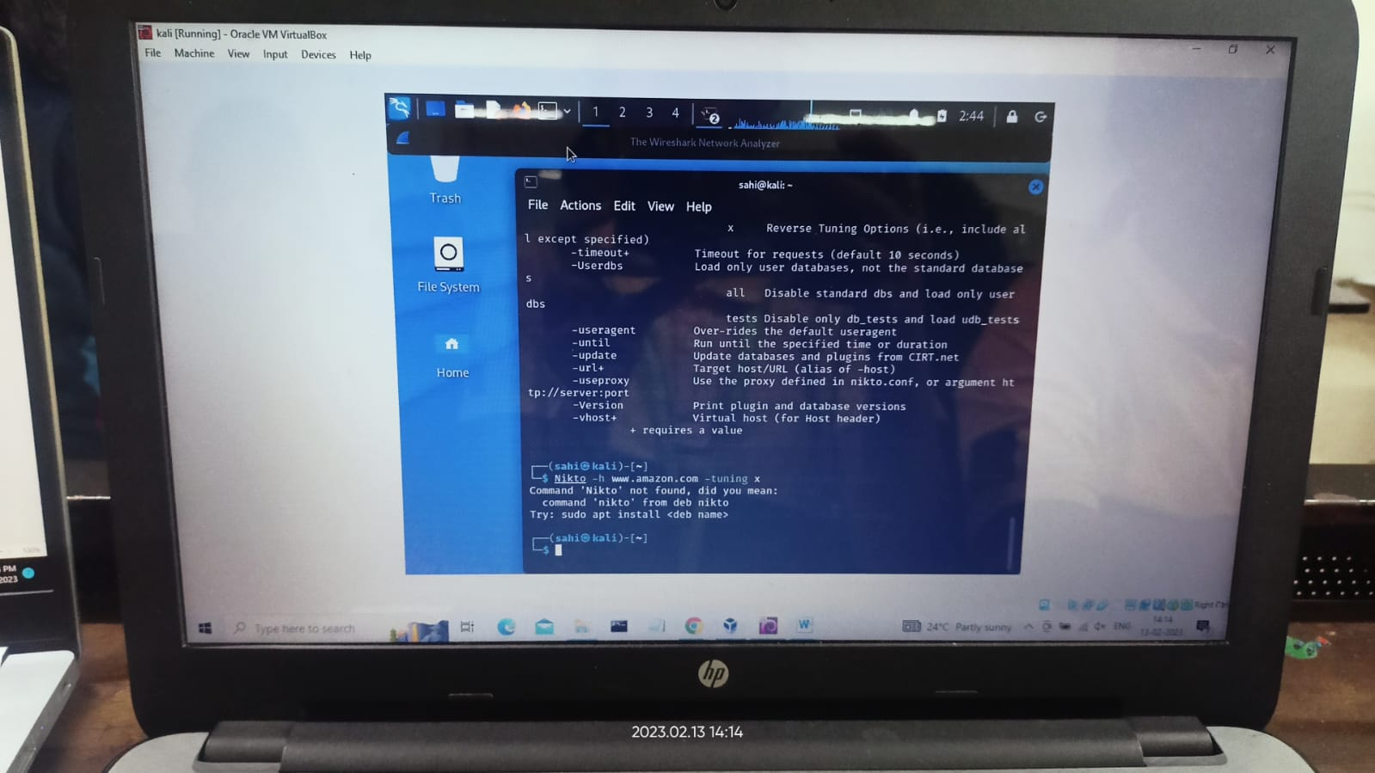

Question 3 2.A network administrator for a company and you have been asked to investigate a possible security breach on the network. Your goal is to use Wireshark to capture and analyze network traffic to identify any suspicious activity. Specifically, you want to examine the packets that use SSDP and look at different header fields and payloads of the concerned packets.

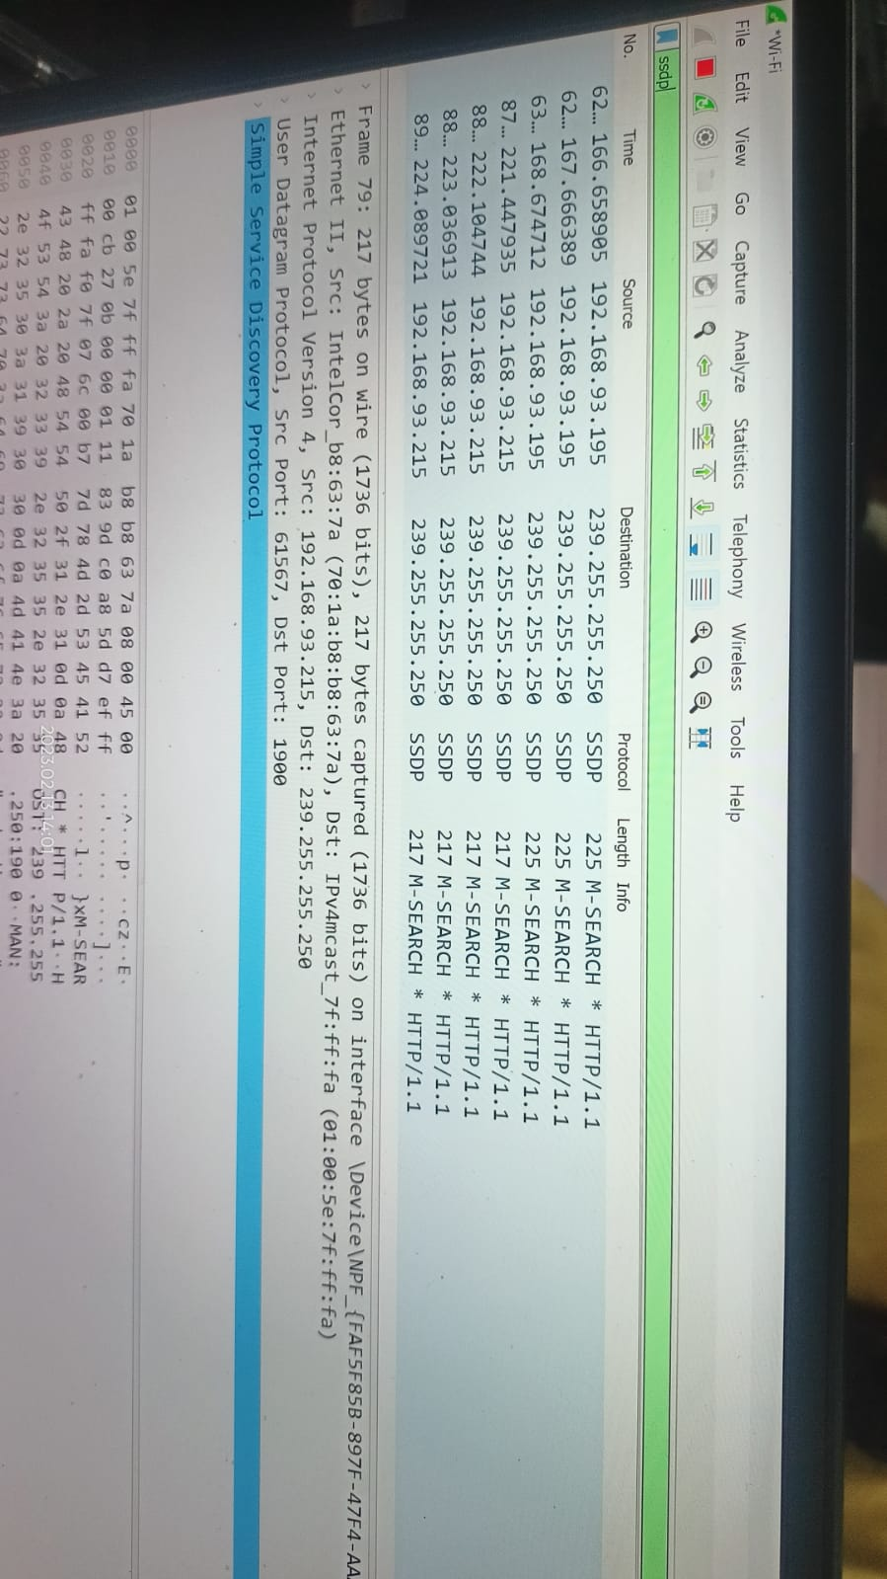

Question 4.2.To execute the following commands in Kali Linux Operating Systems.

mv command

Uname command

Uptime command

